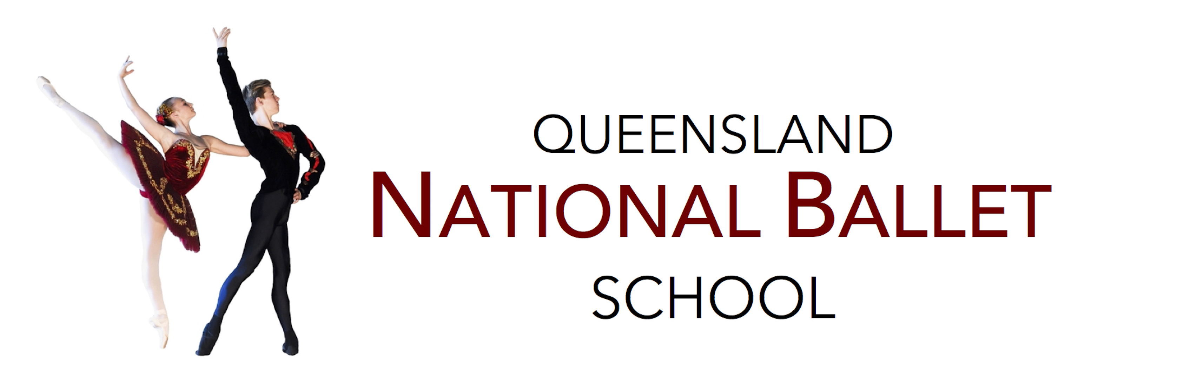

Junior School
Pre- Intermediate Programme
Superior Package - 2019
Tuesday-
4:00-4:45 | Option 1:  Pre-Intermediate ACB Level 1 | BC
4:45-5:15 | QNB Stretching Curriculum | KC
5:30 – 6:00 | Pre-Intermediate Contemporary | KC
6:00 – 6:45 | Option 2:  Pre-Intermediate ACB Level 2 | KC
Wednesday
4:00 – 4:30 | QNB Stretching Curriculum | BC
4:45 - 5:30 | Pre-Intermediate ACB Level 1 & 2 | KC
Thursday
4:15-5:00 | Pre-Intermediate Jazz | KS
5:00-5:45 | Pre-Intermediate ACB Level 1 | CC
5:00-5:45 | Pre-Intermediate ACB Level 2 | TB
6:00 – 6:45 | Junior Acrobatics- Optional extra | KS
Red- Class split, please check which class your child is in Acb Level 1 or 2

3x Ballet Class- ACB Level 1 or 2
2x QNB Stretching Curriculum
1x Jazz Class
1x Contemporary Class

- The Art of Excellence –

