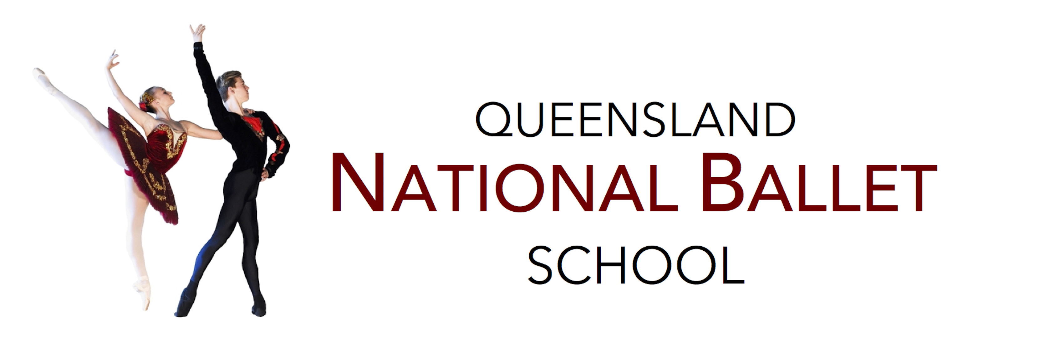

Senior School
Pre-Senior Programme
Superior Package - 2019
Monday
4:30 - 5:30 | Open Classical Ballet Class | KD
5:30 – 6:30 | Pre-Senior Repertoire | KC
6:30 – 7:30 | Pre-Senior Jazz | KS
Tuesday
4:45 – 5:45 | ACB Level 5 | BC
5:45 – 6:30 | Pre-Senior Pointe | BC
Wednesday
4:00- 4:30 | QNB Stretching Curriculum | TB
4:30 – 5:15 | Pre-Senior Repertoire | BC
5:15 - 6:15 | ACB Level 5 | CM
6:15 – 7:15 | Pre-Senior Contemporary | KC
Thursday
4:00-5:00 | Senior Acrobatics- Optional extra | KS
5:00 – 6:00 | Level 6 Ballet- Option extra Class | CC
3x Ballet Class – ACB Level 5
3x Pointe/Repertoire Class
1x QNB Stretching Curriculum
1x Contemporary Class
1x Jazz Class
- The Art of Excellence –

